**Lesson 3: Multiplying and Dividing Integers**

**Do Now:**

**Solve the following problems. Solve the problems using the hot cubes/ice cubes, or using the VIP from the previous lesson.**

1. -2 – (-5) +7 = 10
2. 4+5-10 = -1
3. 9-10+(-1) = -2
4. -7+(-10)-16 = -33
5. 2-8+3=-3

**Key Vocabulary:**

**Guided Notes:**

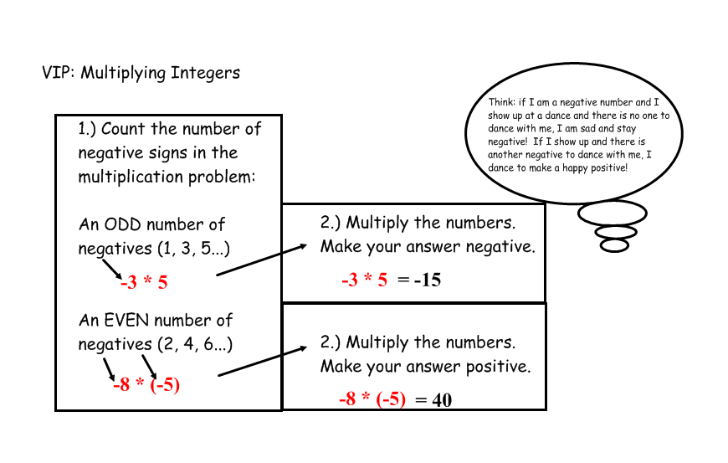

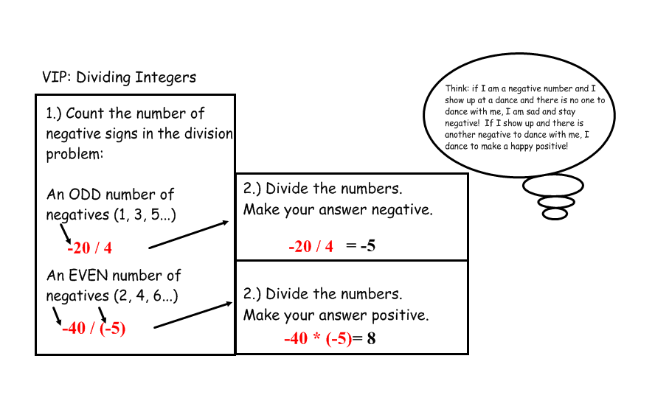

**Multiplication:**

1. 5*-7 = -35
2. -3*-7 = 21
3. -9*0 = 0
4. 2*8 = 16
5. 8*-7 = -56
6. -4*-7 = 28
7. -3*2 = -6
8. -5 * -2 * -1 * ½ * 3 * -2 = 30
9. -1*-1*1*-1*1*-1*1*1*-1*-1*1*-1*1*1*-1*-1*-1 = 1

**Division:**

1. 20/-2 = -10
2. -10/-5 = 2
3. -8/2 = -4
4. 4/2 = 2
5. 500/-10 = -50
6. -100/2= -50
7. -40/-8= 5
8. 2*(4/-2)*(12/3)*-1*(-2/-1)*(-4/2) = -64
9. $\frac{-1×-2×-6}{-2×-4×-3}$ = 1/2

**Structured/Guided Practice:**

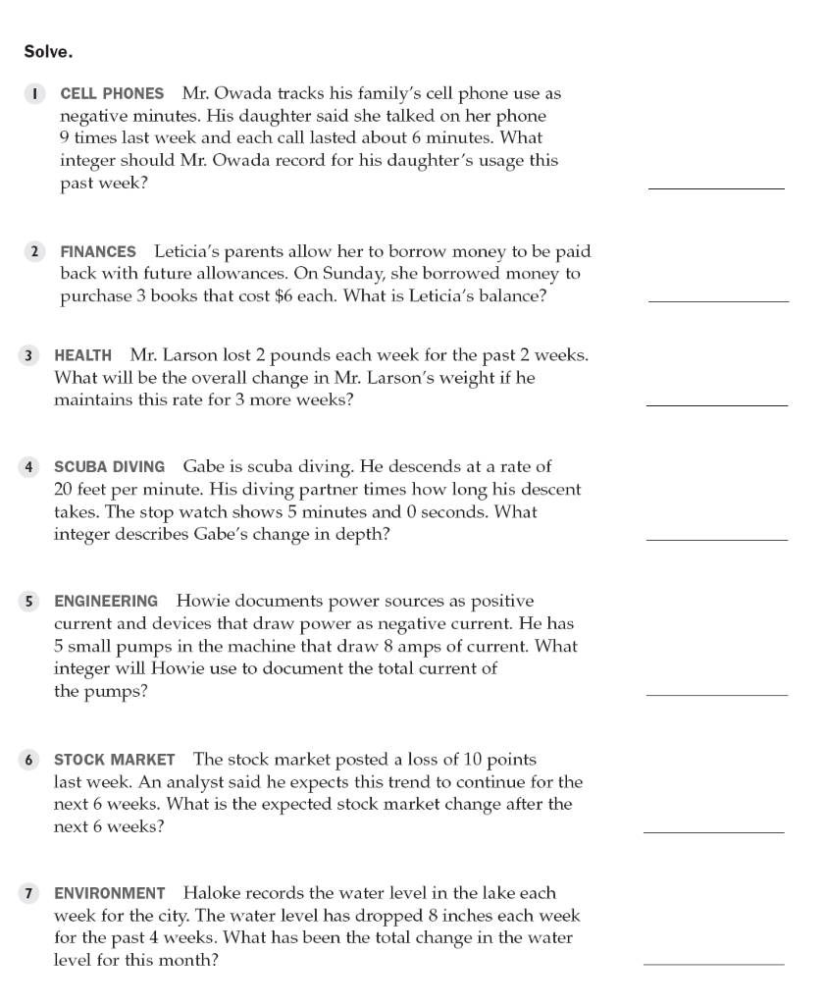

-54 minutes

-$18

-12 pounds

-100 feet

-40 amps

-60

-32 inches

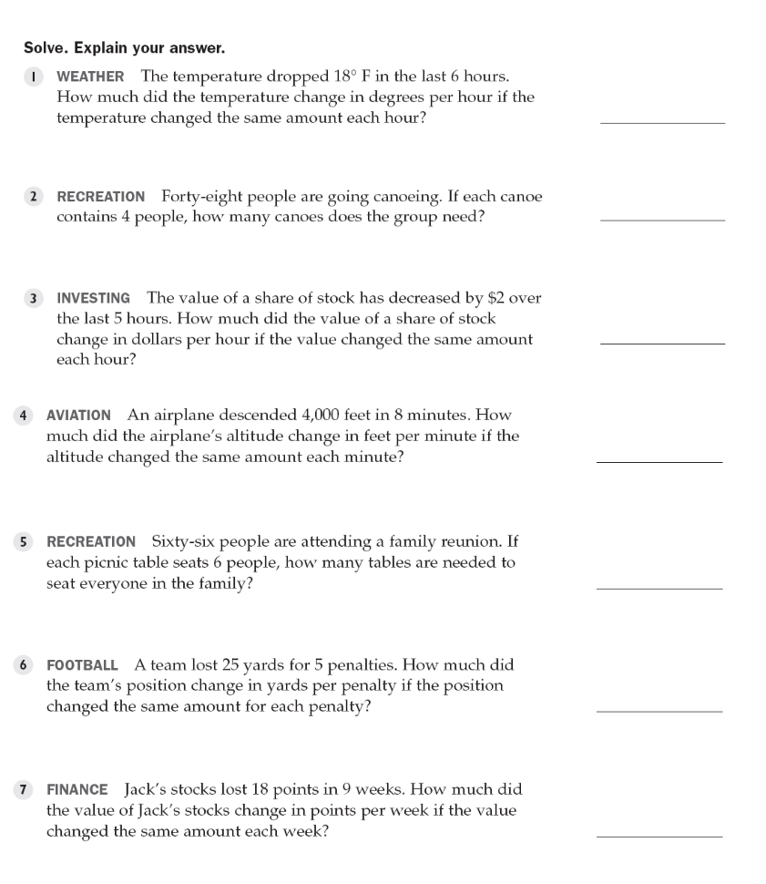

-3 degrees

12 canoes

-$2/5 (or -40 cents)

500 feet

11 tables

-5 yards

-2 points

**Independent Practice:**

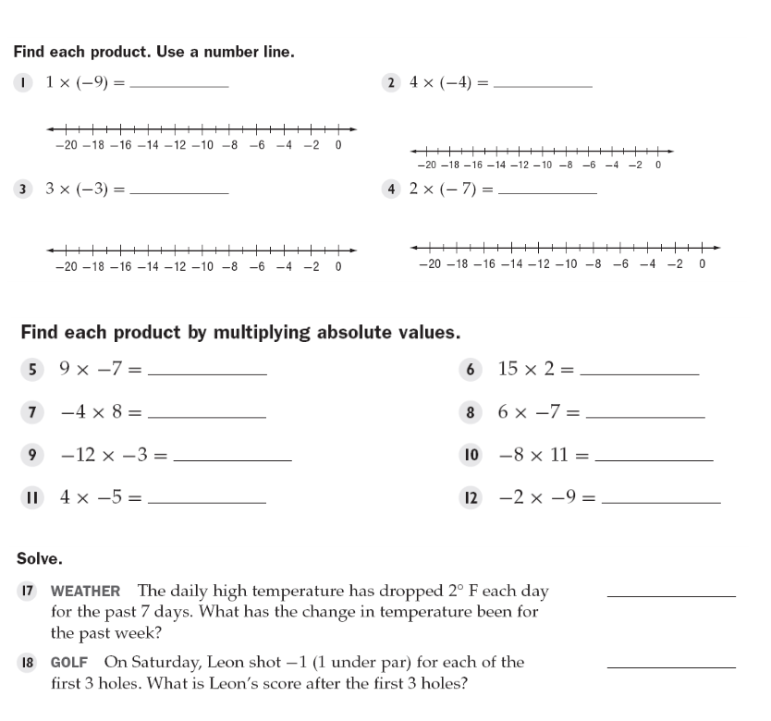

-9 -16

-9 -14

-63 30

-32 -42

36 -88

-20 18

-14 degrees

-3

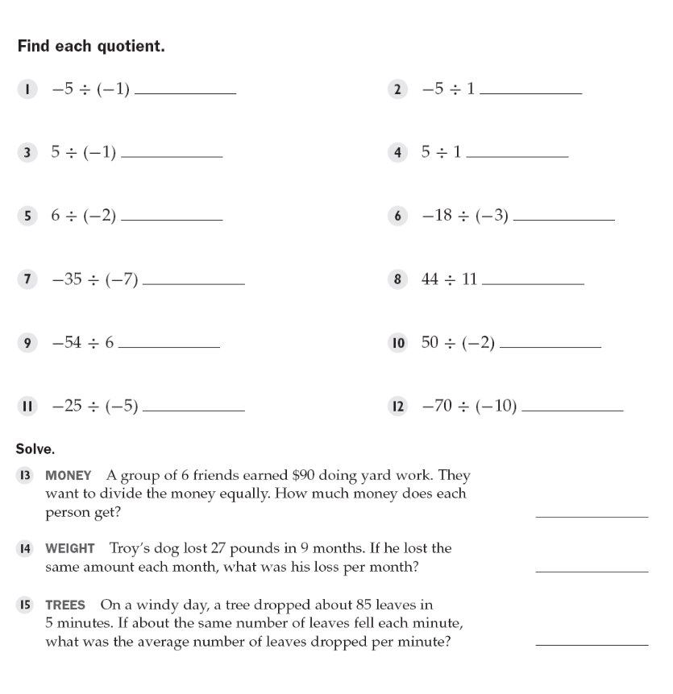

5 -5

-5 5

-3 6

5 4

-9 -25

5 7

$15

3 pounds

17 leaves

**Closure:**

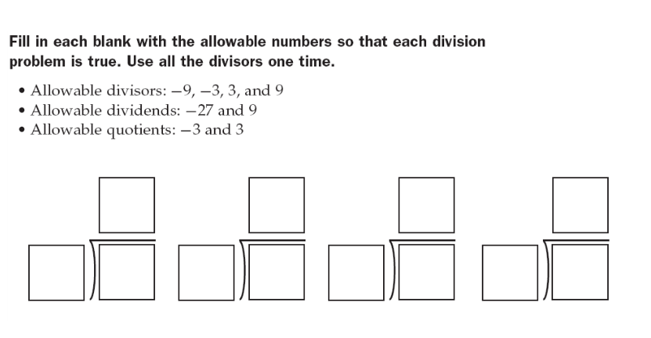

3 -3 -3 -3

-9 -27 -3 9 3 9 9 -27